USC
Learning Isaac Sim, ROS 2 and SLAM
Notes
Liu, Weike
2026-4-27

Table of Contents
1 Using Ubuntu 1
1.1 Using Ubuntu from Windows via Remote Desktop 1
1.1.1 Configuring the Ubuntu Remote Desktop Connection 1
1.1.2 Step 1: Enable Desktop Sharing on Ubuntu 1
1.1.3 Step 2: Configure the Ubuntu Firewall 1
1.1.4 Step 3: Get the IP Address of Ubuntu 1
1.1.5 Possible Problems and Solutions 2
1.2 Using PuTTY to Log In Remotely and Use the Graphical Interface 2
1.2.1 ⚙️ Step 1: Enable the SSH Service on Ubuntu 2
1.2.2 🔌 Step 2: Connect Using PuTTY on Windows 3
1.2.3 🔑 Step 3: Log In to Ubuntu 4
1.2.4 Using GUI Applications Through PuTTY 4
2 ISAAC SIM 7
2.1 Installing Isaac Sim 7
2.1.1 Workstation Setup 7
2.1.2 Isaac Sim Install and Launch 7
2.2 Using Isaac Sim Remotely 10
2.3 Lessons Learned Using Isaac Sim 11
2.4 ISAAC SIM Getting Started 11
2.4.1 Getting Started 11
2.4.2 Synthetic Data Generation for Perception Model Training in Isaac Sim 12
2.4.3 Developing Robots With Software-in-the-Loop (SIL) in Isaac Sim 13
2.5 Using a ZED Camera in Isaac Sim 13
2.6 Installing ROS 2 14
2.6.1 Launch Isaac Sim With ROS 2 Enabled 16
2.6.2 Follow along with an example 17
2.7 Hardware-in-the-Loop (HIL) in ROS 2 and Isaac Sim 17
2.7.1 Setup 17
3 The Isaac Platform 20
3.1 🤖 NVIDIA Isaac Platform: The Robot's "Operating System" 20
3.2 🏗️ NVIDIA Omniverse: The Underlying "Infrastructure" 20
3.3 🏭 Isaac Sim: The "Flagship Factory" 20
3.4 🧪 Isaac Lab: The "AI Training Zone" in the Factory 20
3.5 ⚙️ Isaac ROS: The "Bridge" Between Virtual and Real 21
3.6 🧩 Other Important Components: The Robot's "Professional Toolkit" 21
3.7 💎 Summary and Selection Recommendations 21
4 Installing and Using OceanSim in ISAAC SIM 23
4.1 Installation 23
4.1.1 Clone the repository and download assets 24
4.1.2 Enter the Isaac Sim extensions directory 24
4.1.3 Put OceanSim into it 24
4.1.4 Enable the OceanSim Extension 24
4.1.5 Run the examples 24
5 Get Jetson Ready to Develop 25
5.1 Rebuilding the Jetson AGX Orin 64GB Boot Image 25
5.2 Installing JetPack on the AGX Orin 25
5.3 Installing the ZED SDK on the AGX Orin 25
6 Using the ZED Mini 25
6.1 Getting the Camera Motion Trajectory and Pose 25
6.2 Locating Objects in a Map with ZED SDK YOLO 25
7 YOLO 26
7.1 Training Locally 26
7.1.1 Preparing the Environment 26
7.2 Using YOLO Through the ZED SDK 28
7.3 Ultralytics and YOLO 28
8 Learning ROS 2 29
8.1 ROS 2 Basic Concepts 29
8.1.1 NVIDIA Isaac ROS 30
8.2 Installing ROS 2 30
9 Further Learning Resources 30
10 About RoboSub 30

Using Ubuntu
A remote connection is not required to install Isaac Sim; it is only for convenient remote work.

Using Ubuntu from Windows via Remote Desktop

Configuring the Ubuntu Remote Desktop Connection
Use the built-in Remote Desktop feature of Ubuntu 24.04 (simplest, recommended)
Starting with Ubuntu 24.04, the system has built-in support for the RDP protocol, so your Windows computer can connect without installing any additional software.

Step 1: Enable Desktop Sharing on Ubuntu
Open Ubuntu's Settings.
Click System on the left, then find and click Remote Desktop.
Turn on the Remote Desktop toggle. This allows others to connect remotely.
(Optional) Turn on the Remote Control toggle so you can operate Ubuntu with your mouse and keyboard.
Write down the Username and Password shown at the bottom of the window. These are credentials dedicated to the remote connection and can differ from your login password.
Note: If you don't want the other party to only connect after you log in to Ubuntu each time, you can enable the Remote Login option, which allows connection while the screen is locked or logged out.

Step 2: Configure the Ubuntu Firewall
Open Ubuntu's Terminal and enter the following command to allow RDP traffic (default port is 3389):
bash
sudo ufw allow 3389/tcp

Step 3: Get the IP Address of Ubuntu
In the Ubuntu terminal, enter the ip a command to find your LAN IP address (usually in the form of 192.168.x.x).
Step 4: Initiate the Connection from Windows 11
Type “Remote Desktop Connection” in the Windows 11 search box and open it.
In the “Computer” field, enter the Ubuntu IP address you noted down, then click “Connect”.
In the pop-up window, enter the username and password you saw in the Ubuntu Remote Desktop settings to log in successfully.

Possible Problems and Solutions
The above steps get stuck at the Desktop Sharing screen when going to System and clicking Remote Desktop.
This is usually a minor issue with the system keyring or related components, the same as many people have encountered before.
Try the following in order; the first two methods are the simplest and most likely to succeed.
🔑 Method 1: Initialize the Password Keyring (Highest Success Rate)
This is the most effective solution. Ubuntu's Remote Desktop settings need a default keyring to securely store your login password; if this keyring is broken, the settings screen freezes.
Steps:
Search for and open “Passwords and Keys” in Ubuntu's application menu.
In the left sidebar, check whether the “Login” keyring exists.
If it exists but has a lock icon next to it: right-click it, choose “Unlock”, and enter your system login password.
If it does not exist: click the “+” in the top-left corner, choose “Create Keyring”, name it Login, and set a password (recommended to match your system login password).
After creating or unlocking it, close all windows, then Log Out and log back in to your Ubuntu account.
Go back to Settings → System → Remote Desktop and check whether it has recovered.

Using PuTTY to Log In Remotely and Use the Graphical Interface
Besides Windows Remote Desktop, you can also connect to Ubuntu remotely using a terminal application.
To connect from Windows 11 to Ubuntu 24.04 with PuTTY, you first need to enable the SSH service on Ubuntu, then enter Ubuntu's IP address in PuTTY. The whole process has three steps.

⚙️ Step 1: Enable the SSH Service on Ubuntu
Before you begin, make sure Ubuntu has the SSH server installed and running. Open Ubuntu's Terminal and run the following commands in order:
1. **Install the SSH server** (if not already installed):
```bash
sudo apt update
sudo apt install openssh-server -y
The `-y` flag auto-confirms the installation; you can remove it if you prefer to confirm manually.
2. **Check the SSH service status**:
```bash
sudo systemctl status ssh
If you see the green `active (running)` message, the SSH service has started normally. If it is not running, enter `sudo systemctl start ssh` to start it.
3. **Set SSH to start on boot** (recommended):
```bash
sudo systemctl enable ssh
```
This way, the SSH service starts automatically every time Ubuntu reboots.
4. **Get Ubuntu's IP address**:
```bash
ip a
```
In the output, find your network interface (usually `eth0` or `wlan0`) and note the LAN IP address after `inet`, in the form of `192.168.x.x` or `10.x.x.x`.

5. **(Important) Configure the firewall**:
If you have enabled Ubuntu's firewall (UFW), you need to allow SSH's default port 22:
```bash
sudo ufw allow 22/tcp ```
You can then check whether the rule took effect with `sudo ufw status`.

🔌 Step 2: Connect Using PuTTY on Windows
1. **Download and install PuTTY**: If not installed yet, download the latest version from the [PuTTY official website](https://www.putty.org/) (0.78 or higher recommended for better Ubuntu 24.04 compatibility) and install it.
2. **Open PuTTY and configure the session**:
* In the "Host Name (or IP address)" field, enter the Ubuntu IP address you noted down.
* Make sure "Port" is `22`.
* Make sure "Connection type" is `SSH`.
3. **Save the session for next use** (optional):
* Enter a name under "Saved Sessions" (e.g., "My Ubuntu Server").
* Click the "Save" button on the right.
4. **Click "Open" to connect**.

🔑 Step 3: Log In to Ubuntu
1. On the first connection, PuTTY pops up a security warning asking whether you trust this host. Click **"Accept"** or **"Yes"** to continue.
2. In the terminal window that appears, enter your **Ubuntu username** and **password** as prompted.
3. **Note**: When entering the password, nothing is shown on screen (no `*` appears); this is a normal security mechanism. Press Enter when done.
After logging in successfully, you will see a command-line interface and can start managing your Ubuntu system remotely.

Using GUI Applications Through PuTTY
Use PuTTY + X11 forwarding to connect to a separate remote computer.
If you really need to connect to a **physically separate** Ubuntu computer on the LAN or internet and only want to run one or two lightweight GUI tools (such as a network configuration wizard or `xcalc`), then X11 forwarding is the lighter choice.
**Setup steps:**
1. **Install X Server software on Windows**: The free **VcXsrv** is recommended. After download and installation, running it shows an icon in the system tray.
2. **Install xauth on the Ubuntu server**: Make sure the remote Ubuntu has `xauth` installed; it is required for X11 forwarding.
```bash
sudo apt install xauth
3. **Configure PuTTY**:
* In PuTTY's left navigation pane, go to `Connection` -> `SSH` -> `X11`.
* Check the **`Enable X11 forwarding`** checkbox.
* In the `X display location` box, `localhost:0` usually works.
4. **Connect and test**: Connect to your remote Ubuntu normally with PuTTY. After connecting, try installing and running a small GUI program in the command line to test:
```bash
# Install the x11-apps package, which includes small tools such as the xcalc calculator
sudo apt install x11-apps -y
# Run the calculator; it should appear on your Windows desktop
xcalc
> **Note**: X11 forwarding is not suitable for running large software or a full desktop environment, because network latency and protocol limitations cause a poor experience. When using Isaac Sim, do not enable X11 forwarding in PuTTY.
Here is a summary of the whole process:
Launching a GUI application in PuTTY basically has two steps: first configure PuTTY to enable X11 forwarding, then enter commands in the terminal after connecting. Here is a complete example.
Before you begin, make sure the following conditions are met:
1. **VcXsrv is installed and running**: The VcXsrv you installed earlier needs to keep running; you can see its icon ("X") in the tray at the bottom-right of the Windows taskbar.
2. **A GUI application is installed on Ubuntu**: The GUI software you intend to run on the remote Ubuntu needs to be installed. Below, `xclock` (a classic small clock program) and `gnome-calculator` (calculator) are used as examples.
⚙️ Step 1: Enable X11 Forwarding in PuTTY
This setting tells PuTTY to "hand over" the remote Ubuntu's GUI to the VcXsrv running on your Windows computer for display.
1. Open PuTTY and first fill in your Ubuntu computer's IP address on the "Session" page.
2. In the left navigation tree, find and click **Connection → SSH → X11** in order.
3. In the right panel, **check the "Enable X11 forwarding"** checkbox.
4. **Key step**: In the "X display location" input box, enter `localhost:0` or `127.0.0.1:0.0`.
5. Return to the "Session" page, select "Default Settings", then click **"Save"** to save this session so you don't have to reconfigure next time. When connecting to multiple different Ubuntu hosts, you can also use another session name and save it.
6. Click the **"Open"** button to connect to your Ubuntu computer normally, then enter your username and password to log in.
💻 Step 2: Launch GUI Applications in the Terminal
After logging in, you will see Ubuntu's command-line prompt. Here, just as on the Ubuntu machine itself, you can directly enter the launch command of the GUI application.
**Example 1: Launch a simple clock program**
This is the most classic test command and rarely fails, suitable for verifying whether the whole configuration works.
1. In PuTTY's terminal, enter the following command and press Enter:
```bash
xclock
```
2. If all goes well, a small clock window appears immediately on your Windows desktop. If it does not appear, first check whether VcXsrv is running in the background.
**Example 2: Launch the graphical calculator**
This example is more practical.
1. Make sure GNOME Calculator is installed on your Ubuntu. If not, install it with the following command (a password is required):
```bash
sudo apt update
sudo apt install gnome-calculator -y
```
2. After installation, enter its launch command in the terminal:
```bash
gnome-calculator
```
3. A nice calculator window appears immediately on your Windows desktop, and you can use it like local software.
💡 Some Practical Tips
* **Run in background**: Unlike Windows, after launching a GUI program in the terminal, the terminal stays "occupied". If you want the program to run in the background while the terminal keeps doing other things, append the `&` symbol to the end of the command. For example: `gnome-calculator &`.
* **Difference from WSL**: The biggest difference from WSL is that all computation and programs actually run on **that remote Ubuntu computer**, and your Windows computer only acts as a "monitor". WSL, in contrast, runs Linux on your Windows machine itself.
If no window appears after running `xclock` or `gnome-calculator`, tell me the specific error message and I'll help you find out why.

ISAAC SIM

Installing Isaac Sim
Install Ubuntu 24.04 on the computer and install Samba to set up a network shared folder. Then install Isaac Sim.
There are several ways to install it, such as installing in a Docker container. Here we use:
Option 1: Install from the precompiled binary package (called workstation installation on NVIDIA's website)
This is NVIDIA's official "out-of-the-box" version that perfectly avoids the potential Python and compiler version pitfalls of Ubuntu 24.04, and is currently the most stable and reliable choice.
Create a directory and download: Download the Isaac Sim standalone archive for Linux from NVIDIA's official resources page. Download Isaac Sim — Isaac Sim Documentation.
NVIDIA's official installation steps (Workstation Installation — Isaac Sim Documentation):

Workstation Setup
- Review the requirements. See Isaac Sim Requirements.
- Optionally, for the full development install, make sure you have Visual Studio Code to view and debug source code.

Isaac Sim Install and Launch
The Isaac Sim app can be run directly from the command line with isaac-sim.bat or ./isaac-sim.sh.
The first run of the Isaac Sim app takes some time to warm up the shader cache.
To run Isaac Sim with a fresh config, use the --reset-user flag. This flag can be entered in the Extra Args section of the Isaac Sim App Selector or when running Isaac Sim in command line.
Nucleus, Cache, and Hub are not needed to run Isaac Sim.
- Download the Latest Release of Isaac Sim for your platform to the Downloads folder.
- Create a folder named isaacsim at c:/ or at the root of your Linux environment.
- Unzip the package to that folder：
sudo unzip ShareFiles/isaac-sim-standalone-5.1.0-linux-x86_64.zip -d /isaacsim
- Navigate to that folder.
- To create a symlink to the extension_examples for the tutorials, run the post_install script. The script can be run at this stage or after installation.
  - On Linux, run sudo ./post_install.sh.
  - On Windows, double click post_install.bat.
- Use one of the following methods to run the Isaac Sim App Selector:
  - On Linux, run ./isaac-sim.selector.sh.
  - On Windows, double click isaac-sim.selector.bat.
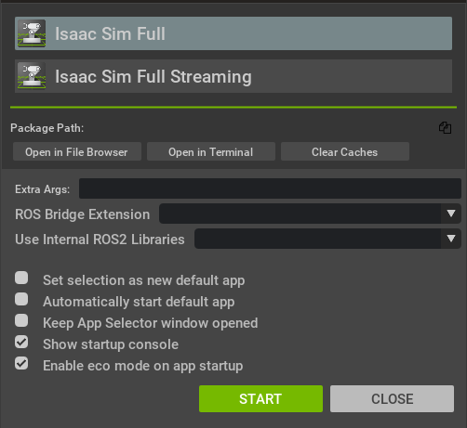
An error occurred at this step: when running isaac-sim.sh, it reported "Failed to create any GPU devices". DeepSeek thought it was a mismatch between the kernel driver and the userspace driver versions. After a reboot, the problem was resolved.
Run `./isaac-sim.selector.sh &` again (when connecting remotely, add `&`, which seems to prevent the network connection from being dropped). It reports "IOMMU enabled". If you run Isaac Sim on a physical machine (not a VM), it is recommended to disable IOMMU; if you use GPU passthrough in a VM, you must keep it enabled. Isaac Sim cannot automatically detect your situation, so it shows this warning every time. To disable it:
sudo nano /etc/default/grub
Find this line in the opened file:
GRUB_CMDLINE_LINUX_DEFAULT="quiet splash"
Add some content inside the quotes and change it to:
GRUB_CMDLINE_LINUX_DEFAULT="quiet splash intel_iommu=off"
Then update and reboot:
sudo update-grub
sudo reboot
After rebooting, verify whether it has been disabled:
bash
# Method 1: Check the dmesg output; there should be no IOMMU-related lines
sudo dmesg | grep -e IOMMU -e DMAR
# Method 2: Check the iommu_groups directory; it should be empty
ls /sys/kernel/iommu_groups/
If neither command produces output, or the directory is empty, IOMMU has been successfully disabled.
- In the popup window choose Isaac Sim Full.
- Click START to run the Isaac Sim main app：./Isaac-sim.sh
A command window opens and runs scripts.
You may need to login to Omniverse.
The command window continues running scripts.
Then the Isaac Sim GUI window opens with nothing displayed in it. It can take 5-10 minutes to complete.
- Proceed to Quick Tutorials to begin the first Basic Tutorial.
Note
There may be situations in which an internal conflict causes failures within the cache and configuration systems of Isaac Sim (for example, if there is a version mismatch between a source installation and a python package installation). If this occurs, the following may prove useful:
- The --reset-user flag can be used to reset the user configuration to its default state.
- The clear_caches.sh and .bat scripts can be used to clear the cache in Linux and Windows respectively.

Using Isaac Sim Remotely
Isaac Sim does not support remote use well. It provides a WebRTC-based way to use it remotely, and you can also use it in headless mode, but that has no GUI.
Using Isaac Sim through PuTTY and X window forwarding is very slow and unusable. Using Isaac Sim through Windows Remote Desktop (RDP) causes connection drops and program exits due to conflicts in GPU usage between the two. NVIDIA officially recommends the headless streaming mode for remote use. Start PuTTY, log in, then:
cd /isaacsim (enter Isaac Sim's installation folder, optional)
/isaacsim/isaac-sim.streaming.sh --/app/livestream/publicEndpointAddress=172.30.30.1 --/app/livestream/port=49100
Using the above command, you can work remotely. But it is somewhat unstable and prone to freezing. Here, 172.30.30.1 is the CloudNet IP address of the computer (server) running Isaac Sim.
Then run the streaming client software downloaded from NVIDIA (https://docs.isaacsim.omniverse.nvidia.com/5.1.0/installation/download.html#isaac-sim-latest-release):
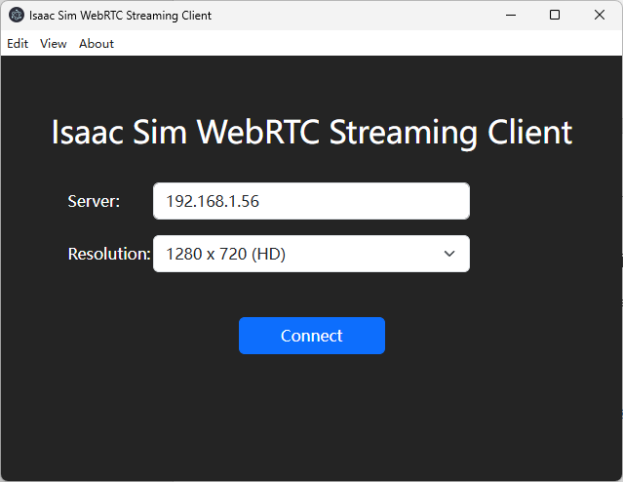
Fill in the Server field with the IP address of the computer running `./isaac-sim.streaming.sh`, then click Connect. This is the way NVIDIA recommends for remote use of Isaac Sim. All other methods are not viable.
In this mode, the display is relatively fast and interactive.

Lessons Learned Using Isaac Sim
1. When using AI to help write scripts to create models, do not give it the PDF; instead give it the drawings as images. It seems to understand the structure only this way.
2. When trying a new script, it is best to restart Isaac Sim, as scripts seem to change some internal settings, causing incorrect results when running scripts.

ISAAC SIM Getting Started
Welcome to Physical AI Learning — Physical AI Learning
Isaac Sim's online resources: Isaac Sim - Robotics Simulation and Synthetic Data Generation | NVIDIA Developer, NVIDIA Isaac Sim · GitHub, and Isaac Sim Requirements — Isaac Sim Documentation

Getting Started
Getting Started With Isaac Sim — Getting Started With Isaac Sim
Follow this link to create your first object, etc.: https://docs.isaacsim.omniverse.nvidia.com/5.1.0/introduction/quickstart_isaacsim.html
This tutorial demonstrates how to create objects, how to let them fall under gravity, and more. It also shows how to do the same things with Python (in two ways).
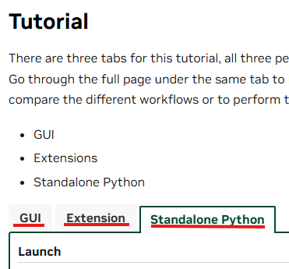
You can use the GUI, extended Python, and standalone Python to create and manage various objects in Isaac Sim, and more.
While using it, if the interface disappears, you can try View-Reload.
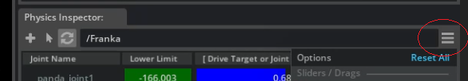
The button with three horizontal lines inside the red circle in the figure above is called the Hamburger icon, because the three lines look like a hamburger.

Synthetic Data Generation for Perception Model Training in Isaac Sim
https://docs.nvidia.com/learning/physical-ai/getting-started-with-isaac-sim/latest/synthetic-data-generation-for-perception-model-training-in-isaac-sim/index.html
The biggest use of Synthetic Data Generation in robot vision/perception model training is to mass-produce high-quality, controllable, precisely annotated data in a simulated environment, so that models become more stable, accurate, and robust in the real world.

Developing Robots With Software-in-the-Loop (SIL) in Isaac Sim
https://docs.nvidia.com/learning/physical-ai/getting-started-with-isaac-sim/latest/developing-robots-with-sil-in-isaac-sim/index.html
In this module, we take a hands-on learning approach to guide you through the SIL workflow, visual programming with OmniGraph, and testing perception models such as image segmentation using Isaac Sim and ROS 2. By the end of this module, you will have the skills to design and run SIL tests for your own robot projects.

Using a ZED Camera in Isaac Sim
This section describes adding a ZED camera to Isaac Sim, then outputting the camera's images and other data to other programs outside Isaac Sim, where image-processing algorithms are run.
In the simulation environment, create a Zed-X camera in the model via Create — Isaac — Sensors — Camera and Depth Sensors — StereoLabs — Zed-X. Place it in a suitable position, then connect it to the rest of the model with a fixed joint.
To output its image data and more to the outside, you need to add an Action Graph. The method is Create — Visual Scripting — Action Graph.
Then in that graph, add On playback tick and zed_camera_helper. Connect them as shown below:
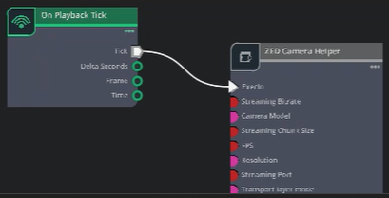
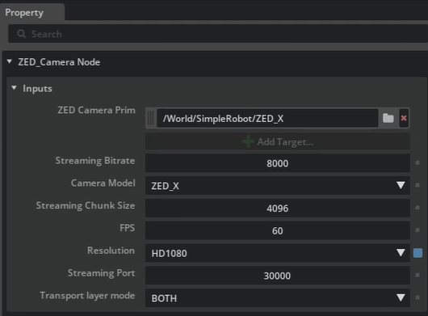
Just set the parameters as shown above.
According to the settings, its data can be output via the network or IPC (inter-process communication). Thus, external programs can use the ZED SDK to obtain data over the network or IPC for SLAM, YOLO, and more. lab4_zed.usd is an example that can be opened in Isaac Sim.
Note: if the Sensor in the figure below is checked, a wifi-like icon will block the front of the ZED-X camera, and its view will also be blocked, so you need to uncheck it.
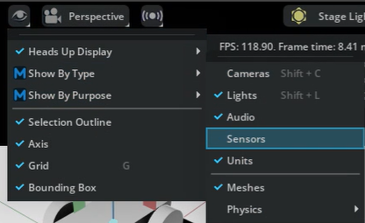

Installing ROS 2
ROS 2 must be installed, and note that the ROS 2 version must match the Ubuntu version.
Platform | ROS 2
Ubuntu 24.04 | Jazzy (recommended)
Ubuntu 22.04 | Humble, Jazzy
Windows 10 | Humble
Windows 11 | Humble
Running sudo apt install ros-jazzy-desktop directly may report an error saying the ROS2 package was not found. This error means the system cannot find the ros-jazzy-desktop package, usually because the ROS software source is not configured.
Steps to resolve:
1. Confirm your Ubuntu version
bash
lsb_release -a
Note: ROS Jazzy only supports Ubuntu 24.04 (Noble). If you use Ubuntu 22.04, you should install ROS Humble; if Ubuntu 20.04, you should install ROS Noetic.

2. Configure the ROS software source
① Add the ROS GPG key
bash
sudo apt update
sudo apt install curl -y
sudo curl -sSL https://raw.githubusercontent.com/ros/rosdistro/master/ros.key -o /usr/share/keyrings/ros-archive-keyring.gpg
② Add the software source
bash
echo "deb [signed-by=/usr/share/keyrings/ros-archive-keyring.gpg] http://packages.ros.org/ros2/ubuntu $(source /etc/os-release && echo $UBUNTU_CODENAME) main" | sudo tee /etc/apt/sources.list.d/ros2.list > /dev/null
③ Update the package list
bash
sudo apt update
3. Install again
bash
sudo apt install ros-jazzy-desktop
4. If it still cannot be found, check the ROS version corresponding to your Ubuntu version
Ubuntu Version ROS 2 Version
24.04 (Noble) Jazzy ✅
22.04 (Jammy) Humble
20.04 (Focal) Noetic (ROS 1)
Quick check command
bash
lsb_release -cs
Output noble → you can install Jazzy ✅
Output jammy → you should install ros-humble-desktop
Output focal → you should install ros-noetic-desktop-full
First run lsb_release -a and tell me your Ubuntu version, and I'll help you confirm which ROS version to install.
After installation, run an example to verify:
In one terminal, source the setup file and then run a C++ talker:

source /opt/ros/jazzy/setup.bash
ros2 run demo_nodes_cpp talker

In another terminal source the setup file and then run a Python listener:

source /opt/ros/jazzy/setup.bash
ros2 run demo_nodes_py listener
You should see the talker saying that it’s Publishing messages and the listener saying I heard those messages. This verifies both the C++ and Python APIs are working properly. Hooray!

Launch Isaac Sim With ROS 2 Enabled
To enable communication between Isaac Sim and ROS 2, enable the ROS 2 bridge.
If you use ROS 2 Humble, Isaac Sim loads the Humble bridge by default, so no extra steps are needed.
If you use ROS Noetic or another ROS version, follow the documentation to enable the ROS bridge extension.
Ensure that your ROS installation is sourced before launching Isaac Sim to avoid fallback to pre-packaged libraries.
Verify that the ROS2 Bridge is enabled:
In Isaac Sim, go to Window > Extensions.
Search for ROS in the search bar.
Confirm that the ROS2 Bridge extension is toggled on

Follow along with an example

Hardware-in-the-Loop (HIL) in ROS 2 and Isaac Sim
https://docs.nvidia.com/learning/physical-ai/getting-started-with-isaac-sim/latest/leveraging-ros-2-and-hil-in-isaac-sim/index.html
Learning objectives. In this module, we will:
Describe hardware-in-the-loop (HIL) systems: explain the purpose and advantages of using HIL in robot testing and how it integrates with the simulation environment.
Install and configure the NVIDIA Jetson: set up the Jetson platform to run robot applications, ensuring all necessary software and hardware configurations are complete.
Perform image segmentation tasks: run an image segmentation model on the Jetson platform and evaluate its performance with real-time data input.
Apply Isaac ROS in real-world scenarios: deploy Isaac ROS packages on real hardware to test robot applications in dynamic environments.
Analyze results from simulation to real-world testing: compare simulation test results with real-world implementations to find differences and optimize performance.

Setup

What You’ll Need
A workstation equipped with an NVIDIA RTX GPU and running Ubuntu 22.04.
The latest version of NVIDIA Isaac Sim installed on your workstation.
An NVIDIA Jetson Orin Nano Developer Kit (or another Jetson Orin model).
A router and Ethernet cables for a wired connection.
A wired connection between your workstation and Jetson is essential. Wi-Fi will not suffice due to the large amount of data exchanged during HIL testing.

Steps to Get Started
Prepare Your Workstation: Ensure your workstation meets the system requirements for Isaac Sim, including an NVIDIA RTX GPU and Ubuntu 22.04.
Set Up the Jetson Orin Nano: Follow NVIDIA’s official instructions to power on your Jetson device for the first time and flash the latest version of JetPack 6.1.
Use a microSD card (64GB or larger) or an NVMe SSD for storage.
Insert the storage device, connect peripherals (keyboard, mouse, monitor), and power on the Jetson.
Establish a Wired Connection: Connect your workstation and Jetson through a reliable router using Ethernet cables.

Connecting to the Jetson
On Windows, it is best to connect to the Jetson with PuTTY. With a network, connect via SSH; without a network, you can connect via serial. If your development computer is not Windows but Ubuntu, open a terminal and connect to the Jetson via SSH, as follows:
To connect to your Jetson from your computer, follow these steps:
Open a terminal on your computer.
Use SSH to connect to your Jetson by typing:
ssh username@remote_IP
Alternatively, use the hostname of your device:
ssh username@<hostname>.local

Installing Jetson-Stats (jtop)
Jetson-Stats (jtop) is an essential tool for monitoring and managing NVIDIA Jetson devices. It provides real-time system performance metrics and helps optimize system resources during development.
Features of jtop
Real-Time System Monitoring: Displays CPU/GPU usage, memory consumption, power usage, and temperature in real-time.
Interactive Interface: A user-friendly command-line interface (CLI) similar to “htop.”
Jetson-Specific Insights: Provides unique data such as power modes, GPU utilization, and thermal warnings.
Process Management: View and manage running processes directly within jtop.
Easy Installation and Updates: Install via pip and keep it updated with NVIDIA JetPack releases.
Configuration Management: Adjust system settings, manage power profiles, and view logs for fine-tuned control.
Python API Support: Integrate monitoring into custom scripts using its Python API.
Installation:
You can install jtop on your Jetson by running:
sudo pip3 install -U jetson-stats
If pip3 is not installed, first run:
sudo apt install python3-pip
If you see an error about the service not being active, run:
sudo systemctl restart jtop.service
If everything is installed correctly, reboot your board. After reconnecting via SSH, type:
jtop
You will now see a detailed system performance dashboard like this!
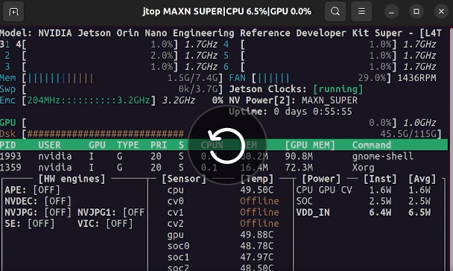

Initializing Isaac ROS on Jetson
The way to install Isaac ROS on the Jetson is similar to installing ROS on the development computer when learning SIL.
For detailed steps, see:
https://docs.nvidia.com/learning/physical-ai/getting-started-with-isaac-sim/latest/leveraging-ros-2-and-hil-in-isaac-sim/03-setting-up-the-jetson-environment.html# in “Set Up the Development Environment”.

The Isaac Platform
These software tools are a complete toolchain from NVIDIA for robot development. With clear positioning and division of labor, they together form a complete ecosystem from simulation to real-world deployment.
To make it clearer, think of them as "hardware, design tools, and factory solutions" prepared for robot R&D:

🤖 NVIDIA Isaac Platform: The Robot's "Operating System"
The Isaac platform is the umbrella term for NVIDIA's entire robot solution. It provides everything needed to build and deploy intelligent robots, from low-level hardware, middleware, and AI algorithms to high-level simulation tools. The Isaac Sim, Isaac Lab, etc. we discuss are all core software tools under this "operating system".

🏗️ NVIDIA Omniverse: The Underlying "Infrastructure"
Omniverse is a low-level, general-purpose 3D collaboration and simulation platform that can be understood as the "foundation" of all upper-layer tools. Based on the OpenUSD universal scene description format and RTX rendering technology, it provides core capabilities such as physics simulation (PhysX engine), ray-traced rendering, and data interoperability.

🏭 Isaac Sim: The "Flagship Factory"
Isaac Sim is a full-featured, high-fidelity robot simulation platform built on Omniverse.
- Purpose: comprehensively test and validate robots in ever-changing virtual worlds and generate synthetic training data.
- Dependency: relies entirely on Omniverse's capabilities to build high-fidelity simulation environments.
You can think of Isaac Sim as a precision factory built on the Omniverse foundation, capable of testing diverse complex scenarios such as physical interaction and lighting in a virtual environment. Its built-in synthetic data generation tools efficiently produce the data needed for AI training, and it also provides a Bridge to communicate with real robot operating systems.

🧪 Isaac Lab: The "AI Training Zone" in the Factory
Isaac Lab is a lightweight, open-source framework focused on robot reinforcement learning (RL) and imitation learning.
- Purpose: designed specifically for AI training, providing standardized training environments and algorithm implementations.
- Dependency: built and runs on top of Isaac Sim.
If Isaac Sim is the all-purpose simulation factory, then Isaac Lab is the "AI training zone" specially carved out in the factory, extremely optimized for algorithm training.
- Difference: compared with Isaac Sim, Isaac Lab sacrifices some non-core features such as visual rendering in exchange for even better parallel training speed, letting developers focus more on the AI policy itself.
- Evolution: it integrated the earlier Isaac Gym; Isaac Gym has been merged into Isaac Lab and no longer gets independent updates.

⚙️ Isaac ROS: The "Bridge" Between Virtual and Real
Isaac ROS is a collection of hardware-accelerated packages based on the open-source ROS 2 framework.
- Purpose: as a "runtime framework", it efficiently deploys AI algorithms to real robots and is the key to moving from virtual simulation to physical reality.
- Dependency: its core NITROS (NVIDIA Isaac Transport for ROS) technology deeply leverages NVIDIA hardware (such as Jetson) for acceleration, enabling real-time processing of algorithms such as perception and decision-making.
Isaac Sim handles simulation in the virtual world, while Isaac ROS handles operation in the real world; together they form a development loop.

🧩 Other Important Components: The Robot's "Professional Toolkit"
- Isaac Manipulator: a dedicated framework based on Isaac ROS that provides end-to-end workflows such as picking, placing, and object tracking, aiming to make robotic arm development and application more efficient.
- Isaac Perceptor: also based on Isaac ROS, designed specifically for 3D environment perception and localization of autonomous mobile robots (AMR/AGV), such as multi-camera surround view and VSLAM.

💎 Summary and Selection Recommendations
Finally, we can summarize the relationships and uses of these core tools in a table:
Tool/Platform | Core Positioning | One-line Explanation | Dependency
NVIDIA Omniverse | Low-level infrastructure / "foundation" | Low-level platform providing 3D collaboration, physics, and rendering capabilities | N/A
Isaac Sim | Flagship simulation platform / "factory" | High-fidelity robot simulator built on Omniverse for testing, validation, and data generation | Depends on Omniverse
Isaac Lab | AI training framework / "training zone" | Lightweight framework focused on reinforcement learning (RL) training for rapid algorithm iteration | Based on Isaac Sim
Isaac ROS | Runtime communication bridge | Deploys AI to real robots, uses hardware acceleration, and connects virtual and real | Independent; works with Isaac Sim
Isaac SDK | (Historical) Robot algorithm framework | Early comprehensive framework providing APIs, tools, and algorithms, now partially evolved or integrated | (Historical) Early integration with Isaac Sim
Isaac Gym | (Historical) GPU-based RL environment | Predecessor of Isaac Lab; independent updates stopped and features integrated | (Historical) Already integrated into Isaac Lab
Isaac Manipulator | Specialized toolkit (robotic arm) | Based on Isaac ROS, providing specialized algorithms and workflows for robotic arms | Based on Isaac ROS
Isaac Perceptor | Specialized toolkit (AMR) | Based on Isaac ROS, providing perception and localization capabilities for autonomous mobile robots (AMR) | Based on Isaac ROS
- How to choose?
Don't be confused by these tools. The choice depends on which stage your project is at and what the core bottleneck is, not simply on judging "which is better":
- For complete robot development: at the early stage of a project or when comprehensive validation is needed, use Isaac Sim directly.
- For focus on AI algorithm training: if the main goal is to train and test robot AI policies (such as reinforcement learning), choose Isaac Lab.
- To deploy algorithms to real robots: when your algorithm is mature in simulation and needs to be migrated to a physical robot for real testing, use Isaac ROS.
- For developing specific types of robots: if your project focuses on robotic arms or autonomous mobile robots (AMR), consider using Isaac Manipulator or Isaac Perceptor in the later development phase to accelerate specific functionality.
- 📅 Evolution Roadmap
Finally, here is a brief evolution roadmap to help you sort out the development history of these tools:
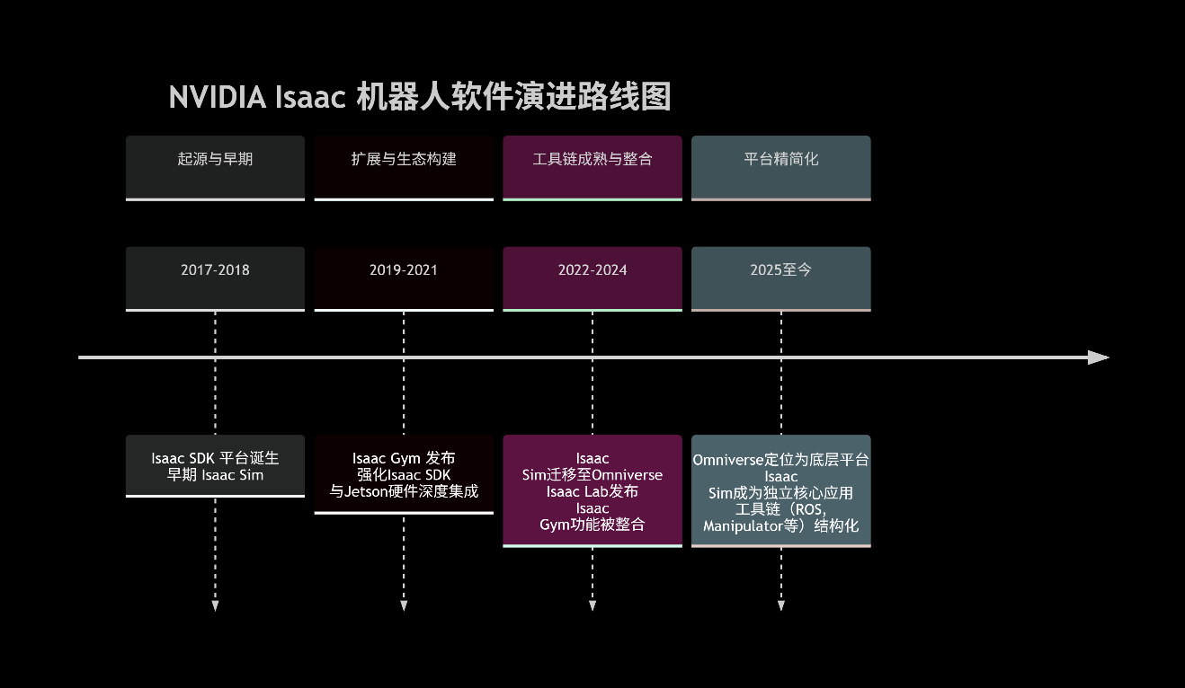
In the figure, you can clearly see that Isaac Gym's features were integrated into Isaac Lab in the later stage, and the Isaac platform has kept evolving, which helps you understand the origins of the existing tools.

Installing and Using OceanSim in ISAAC SIM
This project is: the OceanSim GitHub repository.
It is an "underwater robot simulation platform" developed by the University of Michigan Field Robotics Group (FRoG).
Full project name:
OceanSim: A GPU-Accelerated Underwater Robot Perception Simulation Framework
The corresponding paper has been accepted at the IEEE/RSJ International Conference on Intelligent Robots and Systems 2025.
Its website: https://umfieldrobotics.github.io/OceanSim/?utm_source=chatgpt.com
GitHub: https://github.com/umfieldrobotics/OceanSim

Installation
git-lfs is required, so install it first:
sudo apt install git-lfs

Clone the repository and download assets
git clone https://github.com/umfieldrobotics/OceanSim.git
Clone it into the home directory, i.e., under /home/liuhao.
Then enter the /home/liuhao/OceanSim directory and:
git lfs install
git lfs pull
Download OceanSim_assets from Google Drive (https://drive.google.com/drive/folders/1qg4-Y_GMiybnLc1BFjx0DsWfR0AgeZzA) (it includes USD assets of the robot and environment).
After downloading, run the following script to configure OceanSim to point to the asset path.
cd /path/to/OceanSim
python3 config/register_asset_path.py /path/to/OceanSim_assets

Enter the Isaac Sim extensions directory
Isaac Sim usually has:
isaac-sim/exts/
or:
~/.local/share/ov/pkg/isaac-sim-4.x/exts/

Put OceanSim into it
For example:
cp -r OceanSim ocean-sim/exts/
Or create a symbolic link:
sudo ln -s ~/OceanSim /isaacsim/exts/OceanSim; the symbolic link method is recommended, so use this one. Because it is not added to the startup script, you need to run this command first whenever starting Isaac Sim to use OceanSim.

Enable the OceanSim Extension
Open Isaac Sim, and in the Window → Extensions menu, remove the @feature filter (the default one)
Search for OceanSim and enable it.

Run the examples
The OceanSim repository already has demos.
They usually include:
underwater scene
sonar rendering
camera rendering
digital twin example
You can:
File → Open
Open:
.scenes
.usd
and similar files.

Get Jetson Ready to Develop

Rebuilding the Jetson AGX Orin 64GB Boot Image

Installing JetPack on the AGX Orin

Installing the ZED SDK on the AGX Orin
https://chat.deepseek.com/share/b05sdz2j4br5tejfss

Using the ZED Mini

Getting the Camera Motion Trajectory and Pose
See the Gemini notebook "Camera Pose Estimation".

Locating Objects in a Map with ZED SDK YOLO
To use a pt file in the ZED SDK, you need to convert it to ONNX format. https://platform.ultralytics.com/ is an online conversion tool. https://platform.ultralytics.com/

YOLO

Training Locally

Preparing the Environment

Python, pip

Installing ultralytics [7.2]
pip install ultralytics
After installation, reboot the system, then use the command yolo version to verify that the installation succeeded.
If pip reports errors, you can use pipx:
sudo apt install pipx -y
pipx install ultralytics

Preparing the Data
This is the most critical step.
Transfer the data folder from Windows to Ubuntu:
scp -r C:\Users\your-username\Desktop\MyFolder liuhao@192.168.1.100:/home/liuhao/
Transferring the folder this way avoids the permission problems caused by copying.

The photos and annotation files in the folder need to be organized into the standard format that YOLO understands.
Step 1: Convert annotation files to YOLO format
YOLO model training requires YOLO-format .txt annotation files. Each image corresponds to a .txt file with the same name, where each line represents a target object:
<class-index> <x_center> <y_center> <width> <height>
<class-index>: the class index of the target (starting from 0).
<x_center> <y_center> <width> <height>: the coordinates of the bounding box center and its width and height; these values must be normalized relative to the image width and height (between 0 and 1).
If your annotation files are in VOC format (.xml) or COCO format (.json), you need to convert them to YOLO .txt format first. Many annotation tools (such as LabelImg, mentioned later) can directly select YOLO format when exporting.
Step 2: Organize the folder structure
It is recommended to organize your images and annotation files according to the following structure:
datasets/ # your dataset root directory
├── images/
│ ├── train/ # images used for training
│ └── val/ # images used for validation
└── labels/
├── train/ # .txt annotation files with the same names as the training images
└── val/ # .txt annotation files with the same names as the validation images
Usually, you can put 80% of the data into train and 20% into val.
Step 3: Create a dataset configuration file (.yaml)
Create a .yaml file in the dataset root directory, such as my_dataset.yaml, to tell YOLO where your data is and what classes there are.
# my_dataset.yaml
path: ../datasets/ # dataset root directory; this path is relative to where you run the training command
train: images/train # training image path, relative to path
val: images/val # validation image path, relative to path

nc: 2 # total number of classes
names: ['football', 'player'] # class name list; order corresponds to the indices [citation:9]

Starting the Training
Once everything is ready, you can start training with a single command in the terminal. This is the most convenient way:
yolo task=detect mode=train \
model=yolov8n.pt \ # use pretrained weights to speed up training and improve results [citation:1]; if you have your own model, you can provide your own pt file.
data=/path/to/your/my_dataset.yaml \ # the dataset configuration file you just created
epochs=100 \ # number of training epochs
imgsz=640 \ # input image size
batch=16 \ # batch size; adjust according to your GPU memory
device=0 # which GPU to use; write 'cpu' if only using the CPU
The command line does not support inline comments, so the command actually used is as follows:
yolo task=detect mode=train \
model=yolo11n.pt \
data=./data.yaml \
epochs=100 \
imgsz=640 \
batch=16 \
device=cpuAfter training completes, the best model is saved in runs/detect/train/weights/best.pt; this file is the model you will use for object detection later.
Because yolo11n.pt is used, the command downloads files from GitHub during execution, so ensure your network is available. If the download fails during execution, you can download it from the browser separately and put it in the current directory.
During training, a yolo26n.pt file is also downloaded:
https://github.com/ultralytics/assets/releases/download/v8.4.0/yolo26n.pt
If the download is unsuccessful, you can try a similar approach.
After training, it will indicate where the weight results are, similar to ss:
/home/liuhao/Dataset/runs/detect/train-2/weights/best.pt

Converting pt Files to ONNX Files

Using YOLO Through the ZED SDK

Ultralytics and YOLO
Conclusion: Ultralytics is the current official maintainer and development company of YOLO; the two have a "product-team" relationship, not a competitive one.

Relationship Breakdown
Dimension | YOLO | Ultralytics
Nature | Object detection algorithm / model family | Company + open-source project
Founder | Joseph Redmon (2015, University of Washington) | Glenn Jocher (around 2020)
Versions Covered | YOLOv1 → YOLOv3 (Redmon team) → YOLOv5/v8/v11/YOLO26 (Ultralytics team) | Took over from YOLOv5 and has continued iterating to this day
Open-source library | Algorithm papers + code | pip install ultralytics, integrating the full training/inference/deployment workflow
Key Points
- YOLOv1~v3 were developed by Joseph Redmon; after he left in 2018, the project was dormant for a while.
- From 2020, Ultralytics took over and released YOLOv5 (a PyTorch implementation), followed by YOLOv8 (2023), YOLOv11 (2024), and YOLO26 (2025).
- The ultralytics/ultralytics repository you see on GitHub is the only official codebase of the current YOLO series. The version number of the ultralytics library directly corresponds to the YOLO version (e.g., ultralytics==8.0.x → YOLOv8, ultralytics==8.3.x → YOLOv11).
- Ultralytics not only maintains models, but also provides an all-in-one annotation→training→deployment platform (Ultralytics HUB), supporting export to 19 formats such as ONNX/TensorRT/CoreML, covering edge devices.
One-Sentence Summary
YOLO is an algorithm brand, and Ultralytics is the "official operating team" from YOLOv5 to now. Mentioning modern YOLO is basically the same as mentioning Ultralytics.

Learning ROS 2
https://docs.ros.org/en/jazzy/Installation/Ubuntu-Install-Debs.html

ROS 2 Basic Concepts
ROS 2 is a modular software framework for robotics development. It organizes functionality into “packages” and “nodes,” which handle specific tasks such as image processing, segmentation, or object detection. These nodes communicate with one another to build complex robotic applications. While this module does not dive deeply into ROS 2, understanding its node-based structure is essential for working with Isaac ROS.

NVIDIA Isaac ROS
Isaac ROS is a collection of GPU-accelerated ROS 2 packages designed to enhance robotics workflows. It includes tools for tasks such as object detection, AI-based inference, and image segmentation. In this module, we’ll focus on the Isaac ROS Image Segmentation package, which uses deep learning models like PeopleSemSegNet to perform pixel-level classification of images. This package enables high-performance perception systems by leveraging NVIDIA GPUs for real-time processing.

Installing ROS 2
https://docs.ros.org/en/jazzy/Installation/Ubuntu-Install-Debs.html
https://docs.isaacsim.omniverse.nvidia.com/5.1.0/installation/install_ros.html
You can also refer to: 2.3.1.

Further Learning Resources
https://docs.nvidia.com/learning/physical-ai/
There are several examples to practice.

About RoboSub
Georgia Tech's YOLO training dataset: https://platform.ultralytics.com/zachary-edwards/datasets/georgia-tech-s-robosub-datasetyolov8-obb-1 has a large number of real photos and annotations, and has been cloned to my Ultralytics account: https://platform.ultralytics.com/mantis-gazelle?tab=datasets

https://www.inspirationrobosub.com/2026-robosub-software

https://universe.roboflow.com/robosub-yolo/robosub-yolo/browse?queryText=&pageSize=50&startingIndex=0&browseQuery=true. This website has a large number of real RoboSub photos available for download, and they are already annotated.

